[](https://camo.githubusercontent.com/05ed3919de212efc5a4d5c3630a7b005b1f403e0/68747470733a2f2f692e696d6775722e636f6d2f5941484e564d632e706e673f31)

[**https://github.com/AngelsSoftwareOrg/OneClickZip**](https://github.com/AngelsSoftwareOrg/OneClickZip)

* **One Click Zip**

**by: Ryan Seth Roldan**

|  |
| --- |
| *v1.0.6r1* |

Contents

Description 2

Features 2

When to use this tool? 3

Installation 6

File Association 9

How to 10

Technologies 23

# Description

A GUI application that will let you able to design your own Zip Files individually or filter/dynamic base contents.

After you design your own Zip Files content, you can make a shortcut of your design project that will let you execute it anywhere to launch the program that directly proceed zipping your designed Zip Files Content. It will bypass the Designer GUI and proceed automating your Zip Files content.

# Features

At the surface, this program is like the major Zip File utility programs. You create folders and place files on it. As you place your folders and files on it, it is already zipped on the fly. To compare, this program will let you design first your Zip File structures before committing to Zip It.

Here are the following features this program offered

1. **Dynamic Zip File Name.**

* Useful to prevent overwriting the same zip file if you want to maintain a series of backup

1. **Dynamic Zip Folder Content**

* If your target folder ever increasing on files, you can filter out which of which will be included on the final Zip File.
* It is capable of including sub folder from the target folder
* It will let you filter the files including sub directories files using GLOB like syntax
* It will let you filter the files base on its size and date
* For dynamic folders, it will let you exclude those folders that doesn't contains any files on it. Typical Zip Utility will include all sub folders regardless of what it contains or just an empty folder.

1. **Rename added files before putting on the Zipped File**

* You can rename the original folders and files you selected before putting it on the Zip File

1. **Create a "One Click Zip" shortcut file, to perform zipping your designed folders and files on fly.**

* A very handy feature that will perform Zipping your designed zip file structure anywhere

1. **Place your Zip File in your target folder.**

* Zipping your zip file structure will place the output Zip File into your own choice of folder. This feature will let you organize your files base of your categorization of its content.

# When to use this tool?

Wondering when to use this tool to take it advantages? Here are some of the scenario's I can think of for now where it can be useful...

1. Gaming Save file backup

* I am using a tool called [GameSave Manager](https://www.gamesave-manager.com/) to make a backup of the games save files I've played.
* If you ever had an increasing file count of your gaming save backup, you can make a dynamic folder filter on it and make a Zip File out of it.
* You may ever think you can right click on the backup folder and zip it? Mind not, because, this tool also offers to let you include only those files like (example given out base on the tool capability)
  + Files recently created within 7 days
  + Files which had an actual game save, usually file size exceed let's say 100 bytes

[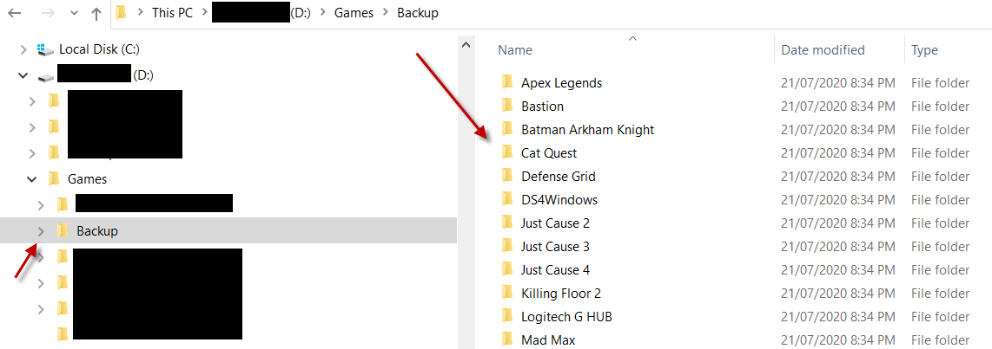](https://camo.githubusercontent.com/b90304f9646946b50f82e0e508e2ce615d57ee92/68747470733a2f2f692e696d6775722e636f6d2f57624e626e394a2e706e67)

1. I'm using this tool to manage my backup of my Password Utility Program called [Keepass Password Safe](https://keepass.info/). Using the Major Zip Utility program, I can make a zip backup of my password manager database. However, I need to do a follow up actions after zipping it:

* Rename the file uniquely
* Maintains several copies of the backup for historical reason. (There are times you can't quite remember what you did and some entries are missing. You can track the missing entries on those historical backups)
* Place this backup to Cloud sync folder, to solidify my backup routine.

[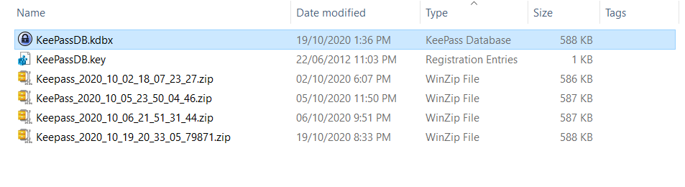](https://camo.githubusercontent.com/375d9f9c6bd1159b97044f40b52a18512f550073/68747470733a2f2f692e696d6775722e636f6d2f7a386f466e72582e706e67)

1. Same reason with #2, I'm using this tool to make a backup of my accounting database. I'm using the Utility Program called [GNU Cash Org](https://www.gnucash.org/)

[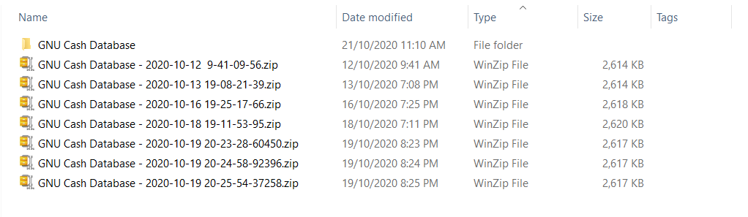](https://camo.githubusercontent.com/7ab812f917306e05d07c7688d169c14511285c7f/68747470733a2f2f692e696d6775722e636f6d2f6c6167477649352e706e67)

1. If you had a meme collection and you are loving it so much, and you want your copies to have a backup, using this tool, you may opt to do the following.

* Zip up normally the current Meme collection folder as your snapshot backup.
* Create a new Zip File Designs. This will target the new files going into your collections.
* In the Project Zip Designer, add a Dynamic Folder, and filter only those files are recently added in your collections. Let say, files that are recently written within a day, within 7 days, a week or a month.
* Place your target folder to place the Zip File Output
* Create a One Click Zip shortcut
* You may run/execute the shortcut every day, or every week, depending on your intent.

As times goes by, people are creative enough to create new memes, and you don't have a good excuse not to love it, thus your collections increase, and the need to back those up will prompt you to do something about it, thus this tool was for you.

[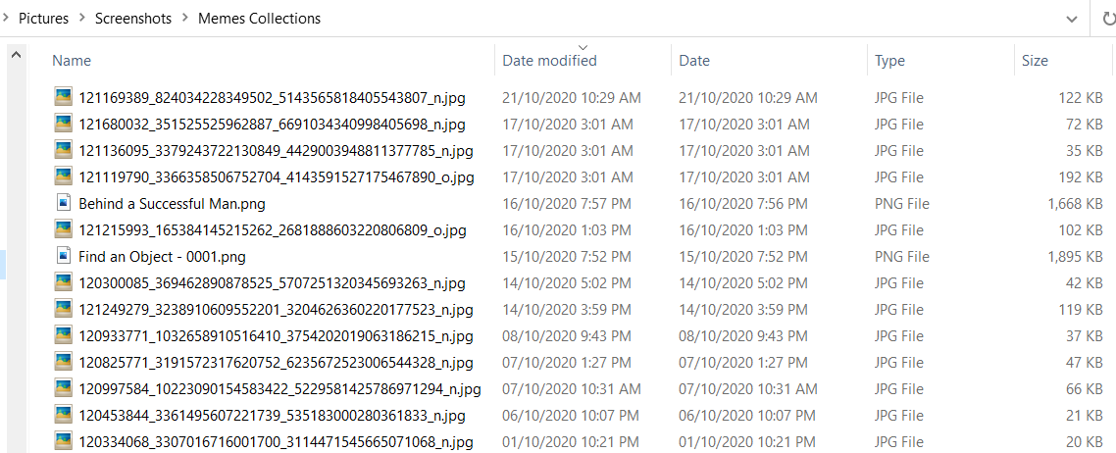](https://camo.githubusercontent.com/97aa8d7f573c5e7eb077c9330b6358709580cef2/68747470733a2f2f692e696d6775722e636f6d2f447239515a66552e706e67)

# Installation

1. Download and extract the latest Installer released on the [One Click Zip Github Release site](https://github.com/AngelsCheeseBurgerOrg/OneClickZip/releases/)

[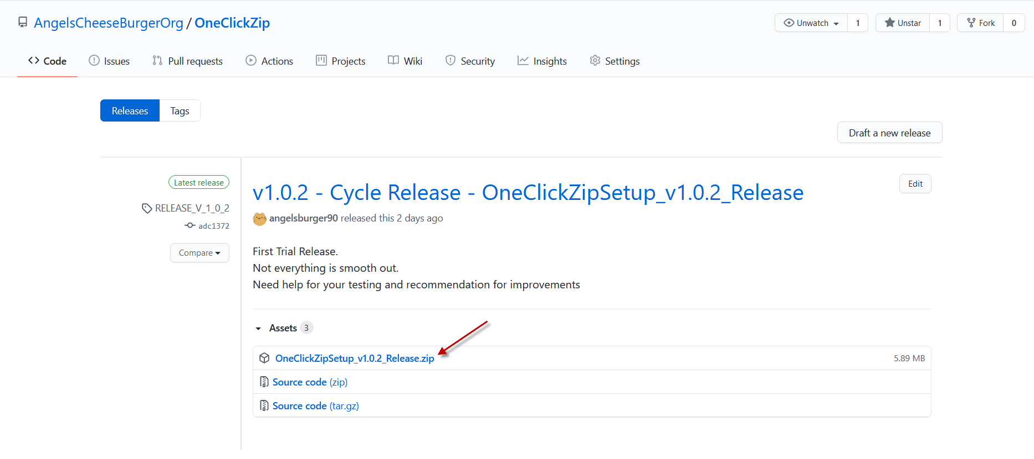](https://camo.githubusercontent.com/433473b4bc0b6a9e09e40d05cf6d4a30e3fe97b8/68747470733a2f2f692e696d6775722e636f6d2f346333794b486a2e706e67)

1. Extract the release Zip File and execute the file as highlighted below

[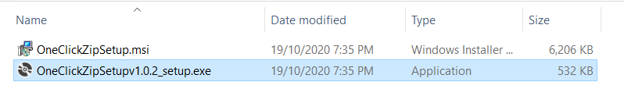](https://camo.githubusercontent.com/2f33cfaef8c52dd5148b5eb8f7056c7743d6d602/68747470733a2f2f692e696d6775722e636f6d2f4c6c7a677966592e706e67)

1. The installer setup is straight forward like any other installers out there.

[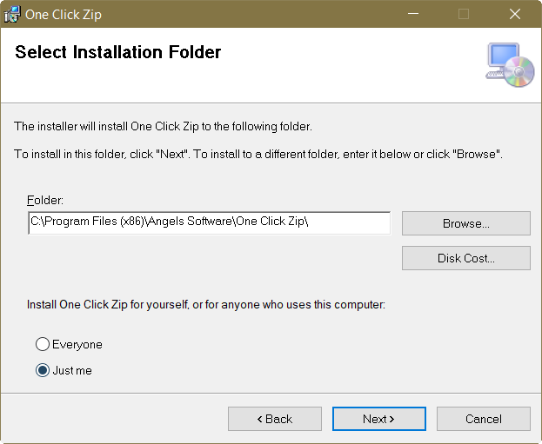](https://camo.githubusercontent.com/888cb53a13cfd7de57b9797f0f24c067dd2b2cd2/68747470733a2f2f692e696d6775722e636f6d2f34354941776f4a2e706e67)

[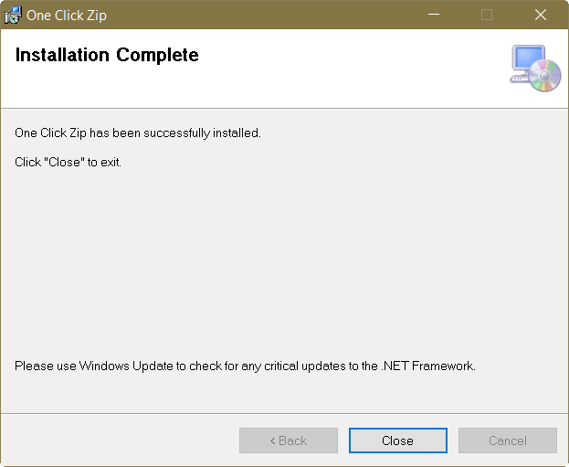](https://camo.githubusercontent.com/0f6b0e54acb0d95a941aa0d8f4a10b6985594828/68747470733a2f2f692e696d6775722e636f6d2f426c554672777a2e706e67)

1. Configuring the File Association. Below is the file association of the program on the File System.

[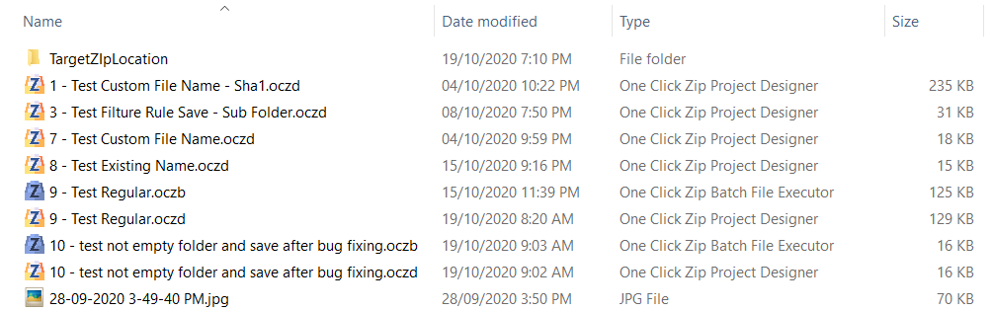](https://camo.githubusercontent.com/6daa6de5caad98779866055d8664b5903709d0a0/68747470733a2f2f692e696d6775722e636f6d2f313473446176712e706e67)

To associate the One Click Zip extension on the file System, open the program and Click the File Association menu option.

[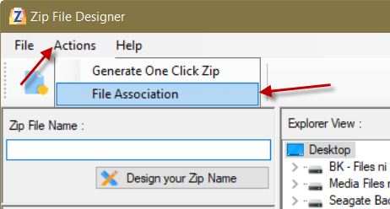](https://camo.githubusercontent.com/d1c91ebd011e84c4992cb24cf4901838ec8bc0a1/68747470733a2f2f692e696d6775722e636f6d2f315266774461422e706e67)

[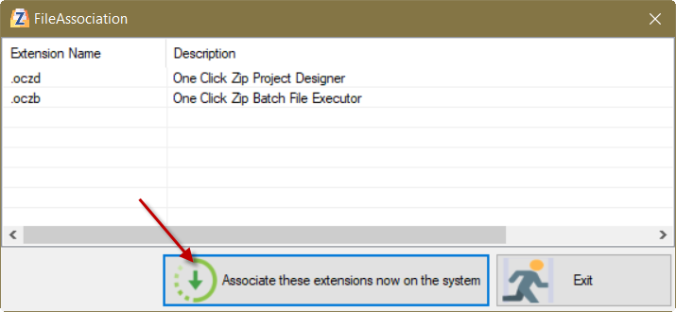](https://camo.githubusercontent.com/a84c6cb88d03d31eb03c2c32f69f49f3db1a0770/68747470733a2f2f692e696d6775722e636f6d2f43556d6243365a2e706e67)

[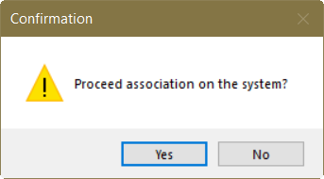](https://camo.githubusercontent.com/e57e4e4caa1132d16db0b680be19aa255291a42d/68747470733a2f2f692e696d6775722e636f6d2f37786a4247624b2e706e67)

[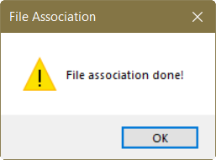](https://camo.githubusercontent.com/7bde7e986b8bec35de87eb4a4c06f614a6e5766f/68747470733a2f2f692e696d6775722e636f6d2f58414f37626a582e706e67)

# File Association

|  |  |
| --- | --- |
| [One Click Zip Designer](https://camo.githubusercontent.com/678903ba4b779f8af158638194c3d0dae0fe2737/68747470733a2f2f692e696d6775722e636f6d2f3178507a4868642e706e67) | This icon represents the Zip File Designer format file. |
| [One Click Batch File](https://camo.githubusercontent.com/3ecf8344b67df1862d2bb9530944fd43f5485d93/68747470733a2f2f692e696d6775722e636f6d2f6e58396e7543332e706e67) | This icon represents the One Click Zip shortcut that can be executed anywhere to produce your **Designed Zipped File** to an actual **Zip File**. |

This is how it seen on the file System

[](https://camo.githubusercontent.com/6daa6de5caad98779866055d8664b5903709d0a0/68747470733a2f2f692e696d6775722e636f6d2f313473446176712e706e67)

# How to

In this section, I will guide you how to use the tool. Below are the outlines of the major use of tool.

1. **How to Design your Zip File**

* Open the One Click Zip program

[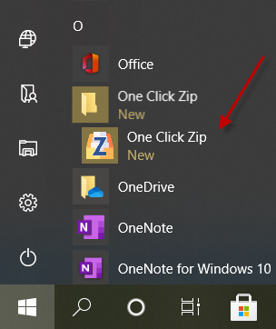](https://camo.githubusercontent.com/eacfb9552dba66488319465b3280a187671d2d0d/68747470733a2f2f692e696d6775722e636f6d2f455144323549372e706e67)

* You can add or drag and drop your target files into the designer

[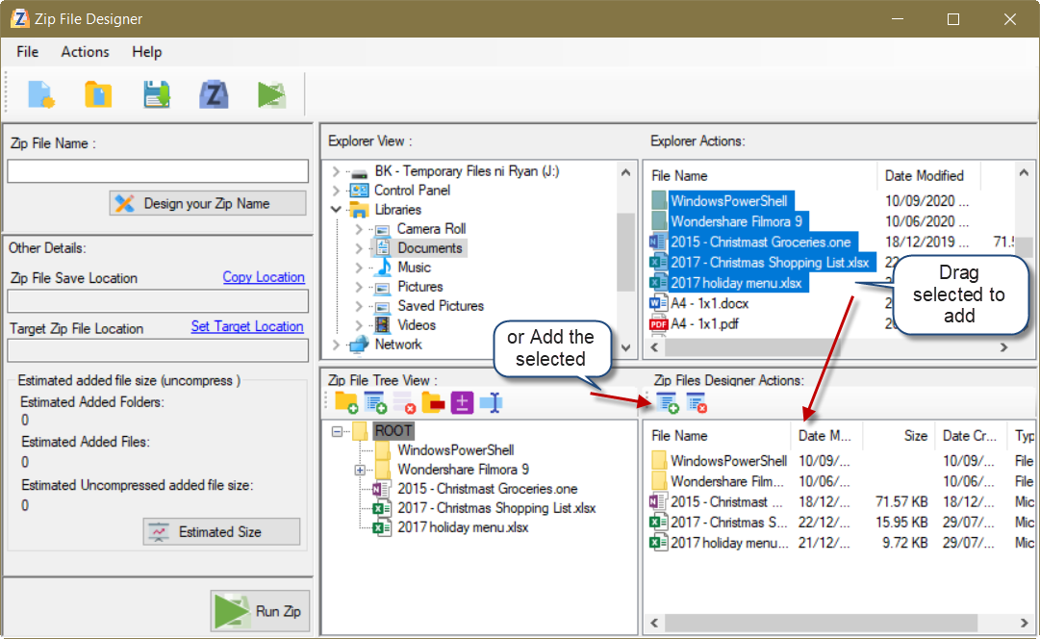](https://camo.githubusercontent.com/bcdfbf1cfebba0f2001c5bdc131d1ac70e3cf54b/68747470733a2f2f692e696d6775722e636f6d2f504f34354962722e706e67)

* You can even rename the added folders and files

[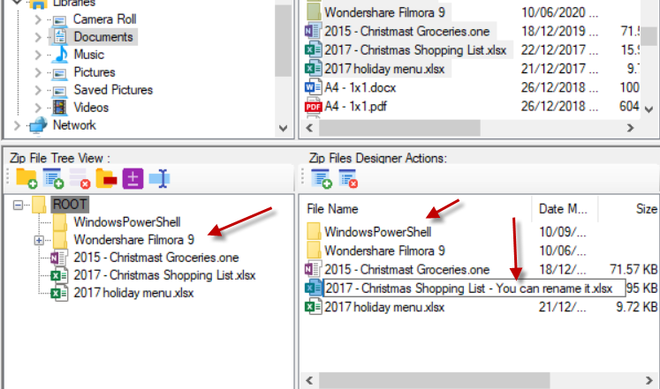](https://camo.githubusercontent.com/b5e75600256cd7253667add08ea4fca36092bb99/68747470733a2f2f692e696d6775722e636f6d2f50347839376f302e706e67)

* Now then, we'll specify the designer Zip File name. The best name is dynamic one so that it prevents to overwrite the same file if your intent is for back up purposes.

[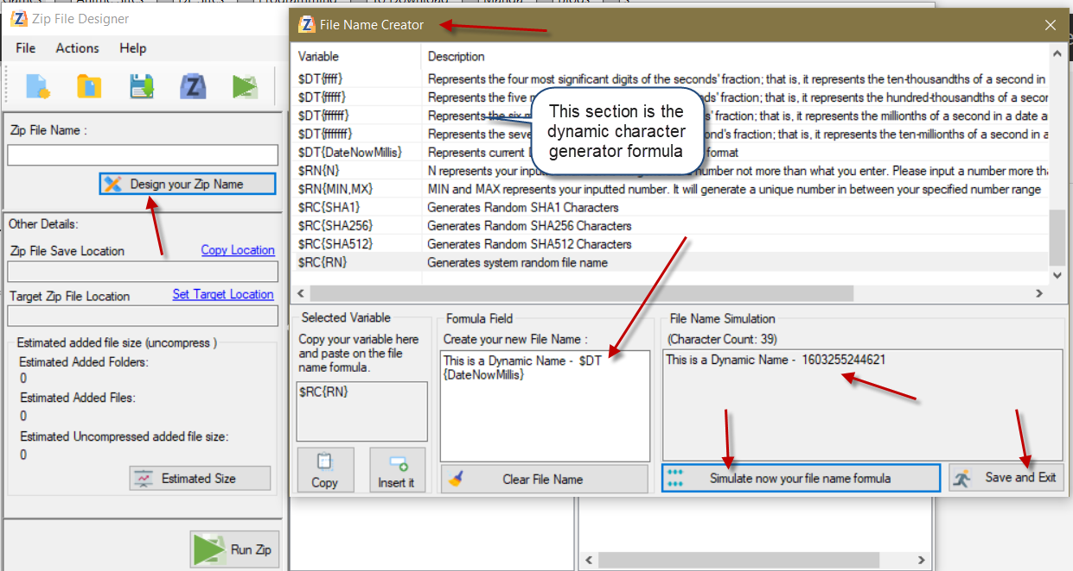](https://camo.githubusercontent.com/d0bba6af5c4eff9a78e04c02e2004d0b94790305/68747470733a2f2f692e696d6775722e636f6d2f314636653479312e706e67)

* Then, select your target folder to place the Zip File output

You can also specify other folders as a copy-to destination after this utility finishes its archiving your zip design…

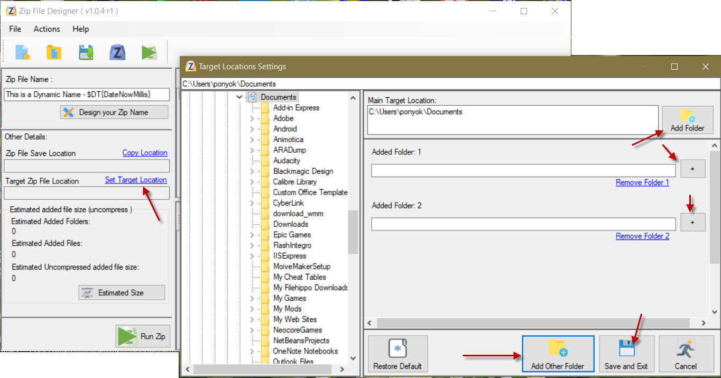

* You can now run the zip file within the Zip Designer and Save your project.

Running the Zip packaging is not mandatory within the Designer.

However, this will let you test if the desired outcome of what you've design is within expectation specially if you had a Dynamic Folder Filter added.

[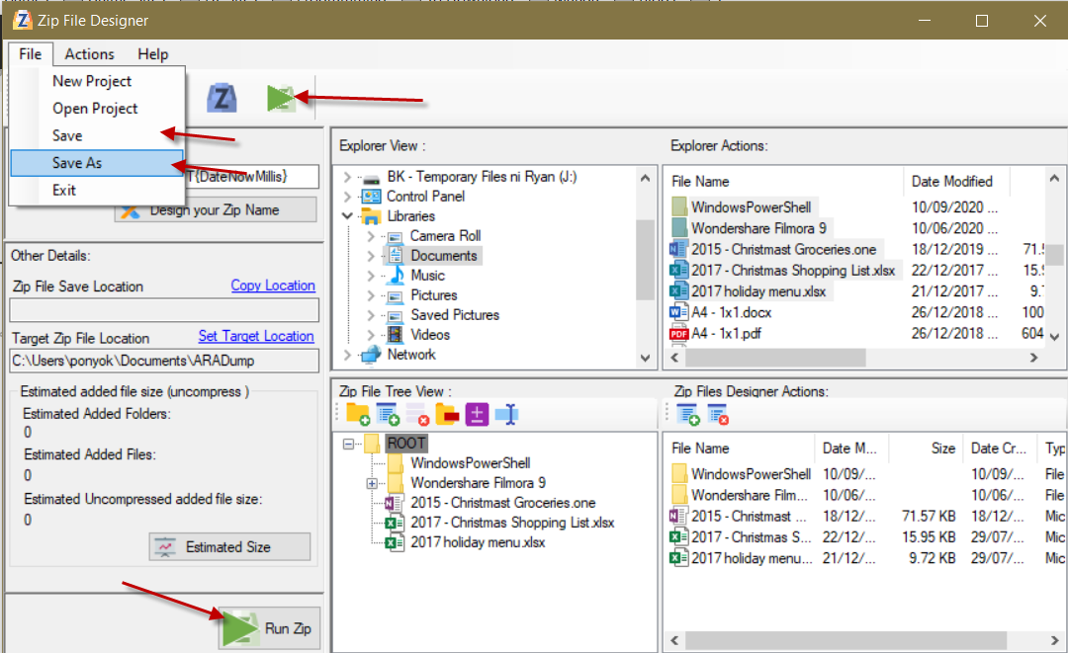](https://camo.githubusercontent.com/823221a7f0177a3f1f7a2ee7728d2f9d461ed4d9/68747470733a2f2f692e696d6775722e636f6d2f377349475267532e706e67)

* Successful zip packaging looks like this...

[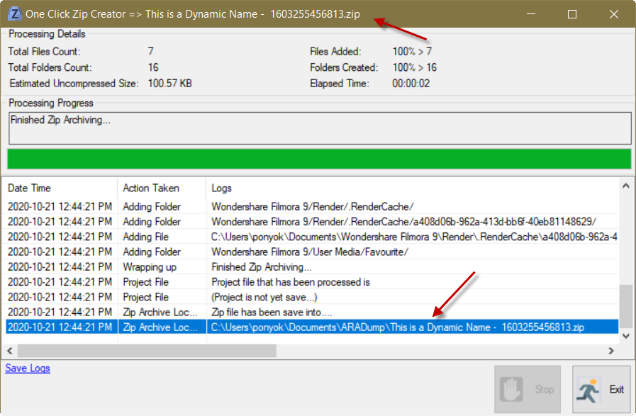](https://camo.githubusercontent.com/6273c7b6137d24991db4bf3103084ab6933a1e70/68747470733a2f2f692e696d6775722e636f6d2f76657851534b712e706e67)

* This is the generated Zip File containing what you've added on the Designer and placed on your desired Target/Drop off folder

[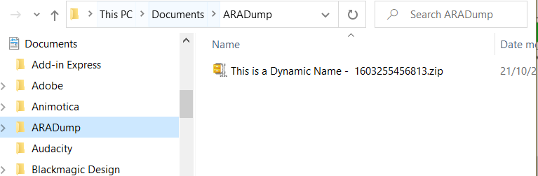](https://camo.githubusercontent.com/47a0a3d24467e083707cbb0011006570beb911f4/68747470733a2f2f692e696d6775722e636f6d2f736f6d7649516f2e706e67)

* Saving your Designer

[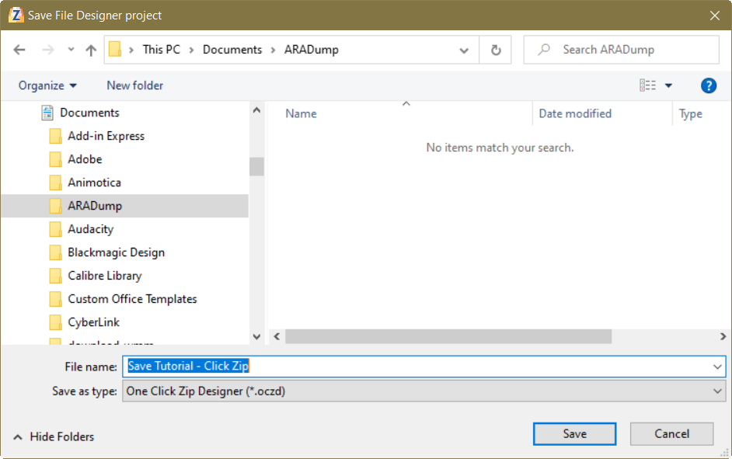](https://camo.githubusercontent.com/7888a678e9e5cb2303f15340495aa4fce8b51e6d/68747470733a2f2f692e696d6775722e636f6d2f394c305a4538482e706e67)

* Saved Zip Designer Project file [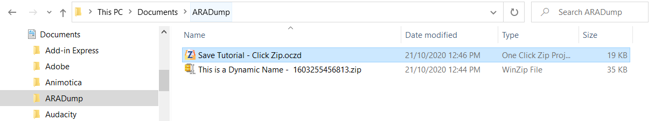](https://camo.githubusercontent.com/184e90d045532704c9f02d1b499ebbfaec86b434/68747470733a2f2f692e696d6775722e636f6d2f4252686f5237322e706e67)

1. **Creating Dynamic Folder Content**

* You may create a Dynamic Folder by clicking a Folder on the Tree View and click the **Add Filter Rule/Node**, or right click a folder and select **Add Filter Rule**

[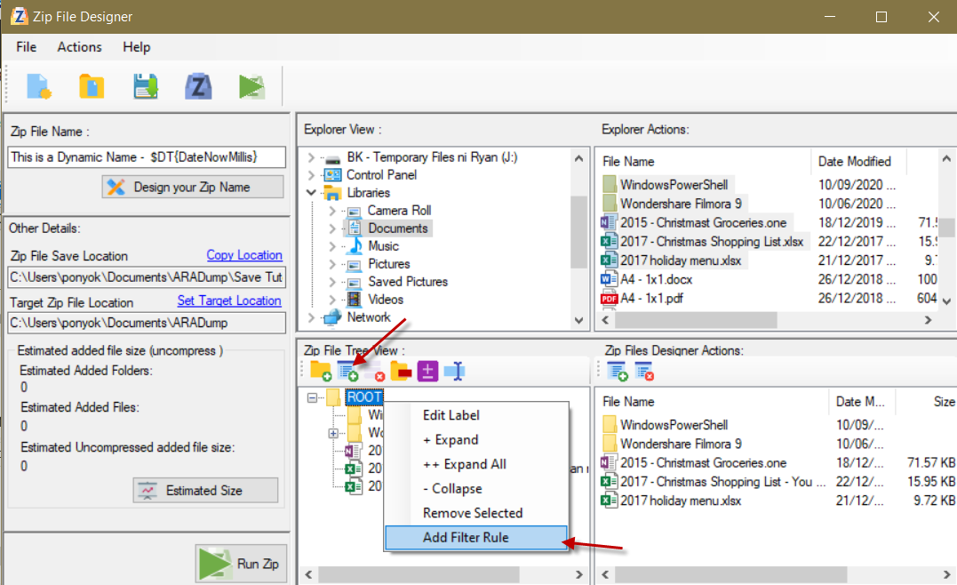](https://camo.githubusercontent.com/8ede338fbc4fe31959e1eb0f74ac90b1819be672/68747470733a2f2f692e696d6775722e636f6d2f4b49434f7934662e706e67)

* A new window dialog will appear.
* You may want to start choosing which is your target folder to extract contents to
* By default, all contents of the target folder will be added. We can create our own rule to specify which contents to extract only out of all the contents containing on the target folder like below.
* If you need some complex filtering rule, you may refer to the Filter help **(Pattern helper)** on the right side

[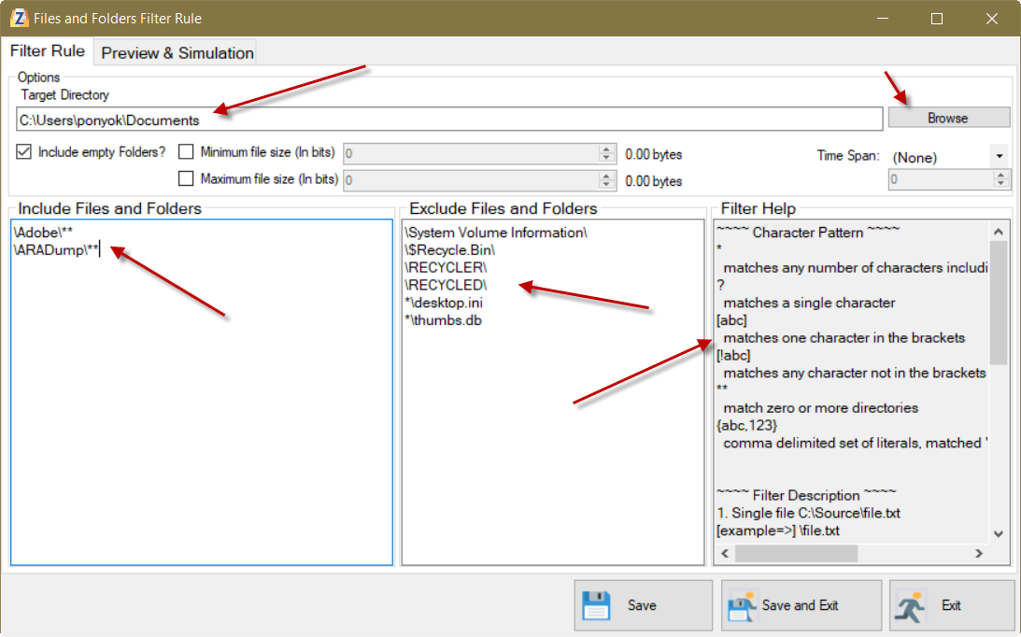](https://camo.githubusercontent.com/8a0c7cb3b595ac0104a64c9de6560c14f909e397/68747470733a2f2f692e696d6775722e636f6d2f516e52735350552e706e67)

* To test out if your filter rule was really working, click the **Preview & Simulation** tab. Just click the **Start Preview/Simulation** button. You can see the affected folders and files matching your filter rule, in which it will include in your Zip Designed output file. If you are now content with your filter rule, click Save and Exit to bind it on the added **Dynamic Folder**.

[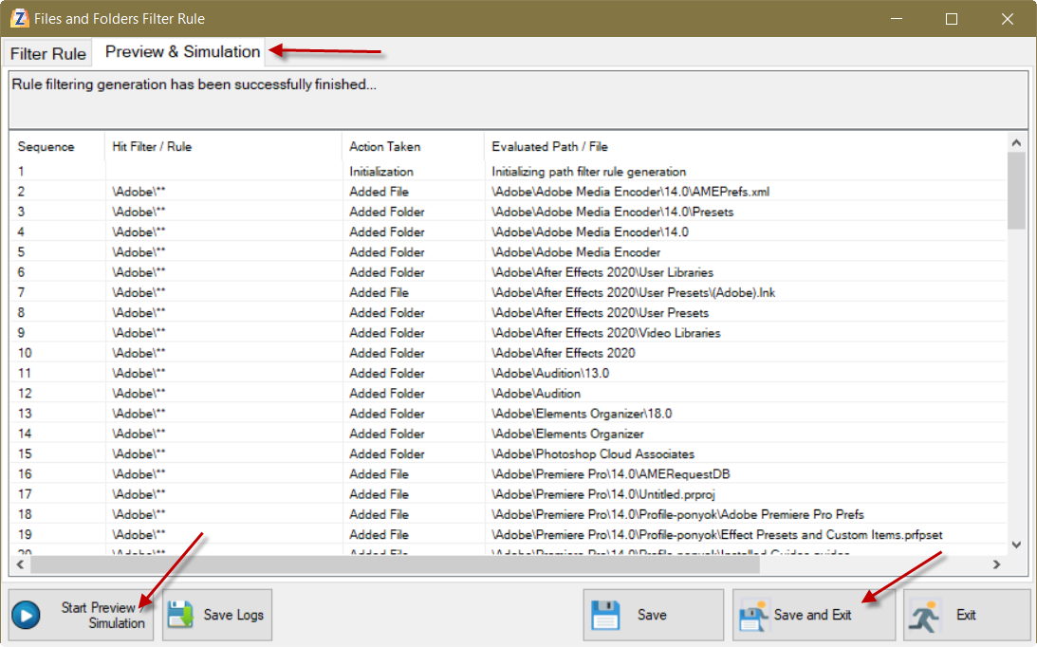](https://camo.githubusercontent.com/256ff0fe37f1e3b48e227bff3cb8d6cabf74a236/68747470733a2f2f692e696d6775722e636f6d2f5561443949326b2e706e67)

* Once you exit the **Filter Rule Designer** window, you will opt to place the folder name of your choice

[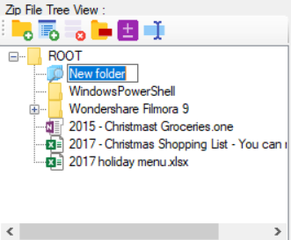](https://camo.githubusercontent.com/2f1be42a428d8c2250ecb6c48864dfdb377d9963/68747470733a2f2f692e696d6775722e636f6d2f336a44664a42512e706e67)

* If you want to modify your filter rule on it, just **Double Click** the folder, or **Right Mouse Click**, then choose **Modify Filter Rule**

[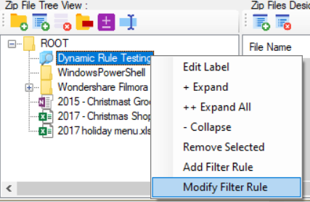](https://camo.githubusercontent.com/e6b80c3922619a6624c77f37c8bfeff116d5555a/68747470733a2f2f692e696d6775722e636f6d2f5166346f7453782e706e67)

* Run the Zip Packaging and see the result

[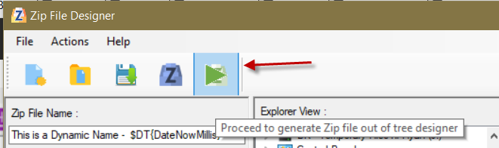](https://camo.githubusercontent.com/dedbcf82a510cc4cba19a8f4e9d2f012cb1a0b64/68747470733a2f2f692e696d6775722e636f6d2f76535557756c762e706e67)

Finished Archiving

[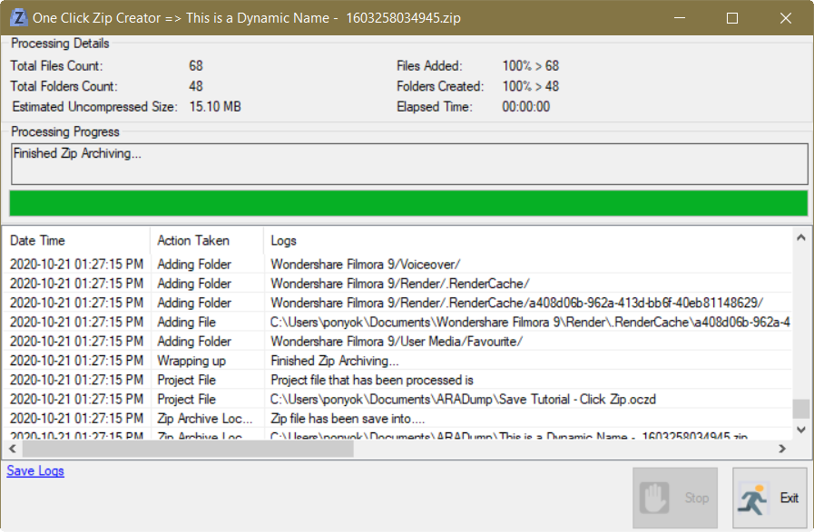](https://camo.githubusercontent.com/05fee04032c9f1282a1a0344c8623939b1e5ca6c/68747470733a2f2f692e696d6775722e636f6d2f37786e736a4f442e706e67)

Here's the generated Zip File

[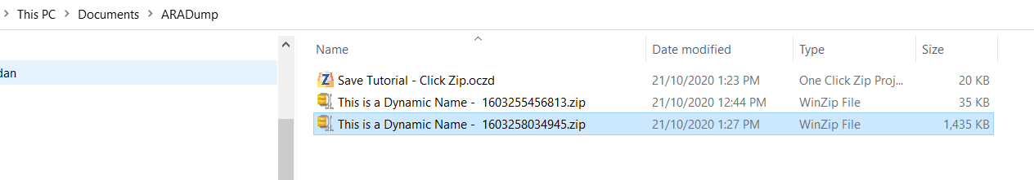](https://camo.githubusercontent.com/c2fd351f092b3b531c1de0d0493550fba0db87e9/68747470733a2f2f692e696d6775722e636f6d2f50786e7a5476412e706e67)

It now contains the two filtered folders content we set out earlier

[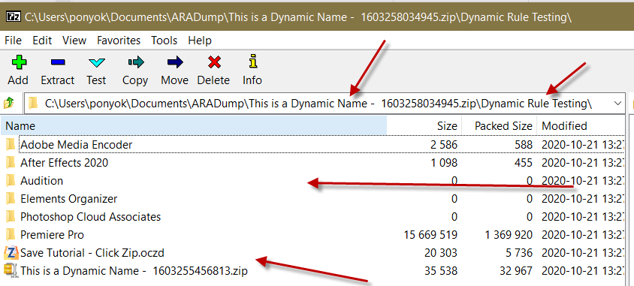](https://camo.githubusercontent.com/54507785fd8d34971f29bc17915d117fd6ef843a/68747470733a2f2f692e696d6775722e636f6d2f716d7a44385a312e706e67)

1. **Creating One Click Zip Shortcut**

* If you have followed the #1 and #2 guide, you are now ready to convert it to a Shortcut.
* There are two ways to make a shortcut
  + First is from **Actions menu**

[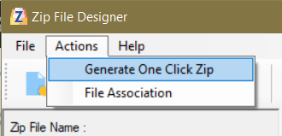](https://camo.githubusercontent.com/2b25fb446e0a491fb6b038bb88650ea1ce148584/68747470733a2f2f692e696d6775722e636f6d2f567268524f496c2e706e67)

* + Second is on the tool bar

[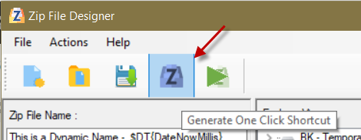](https://camo.githubusercontent.com/e9346e4537ab9395beaa50ef3219190e5b9be42e/68747470733a2f2f692e696d6775722e636f6d2f4733504e7458782e706e67)

* Choose where to place your shortcut

[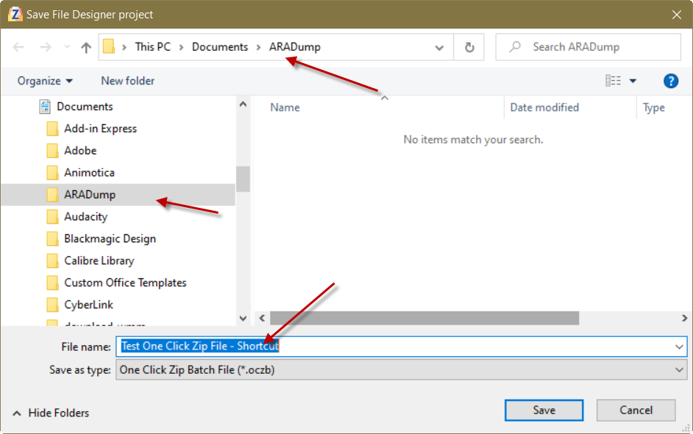](https://camo.githubusercontent.com/24e6b1ca9da51a7f3477c3a391aaca401d104f52/68747470733a2f2f692e696d6775722e636f6d2f427068325439652e706e67)

[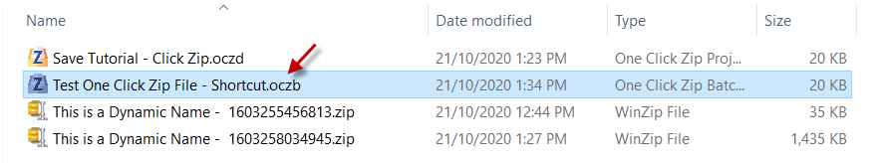](https://camo.githubusercontent.com/c603c74a471e07419ada0996594aeb88b904cd34/68747470733a2f2f692e696d6775722e636f6d2f57446f31464d522e706e67)

* Double click the shortcut to execute and start the Archiving Upon execution, the program goes directly to archiving

[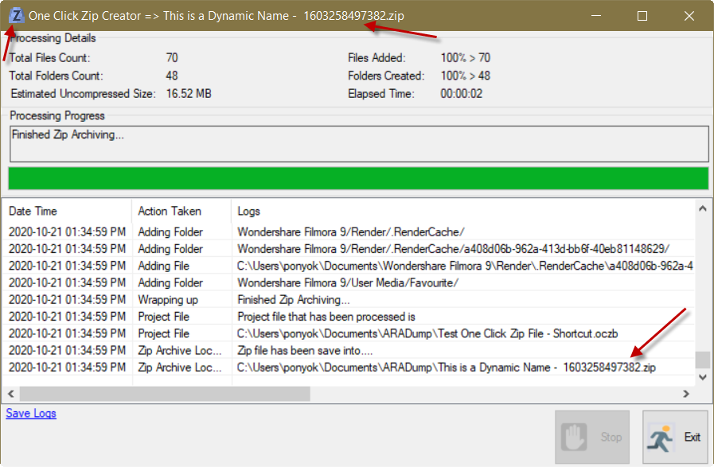](https://camo.githubusercontent.com/2d1276eb161cd6b614f10db09ba31b060528104a/68747470733a2f2f692e696d6775722e636f6d2f48446d736364552e706e67)

* Open the generated Zip Archived. Inside, we notice that there were several items were added including our shortcut. This is because our filter rule says to include all files in that folder dynamically.

[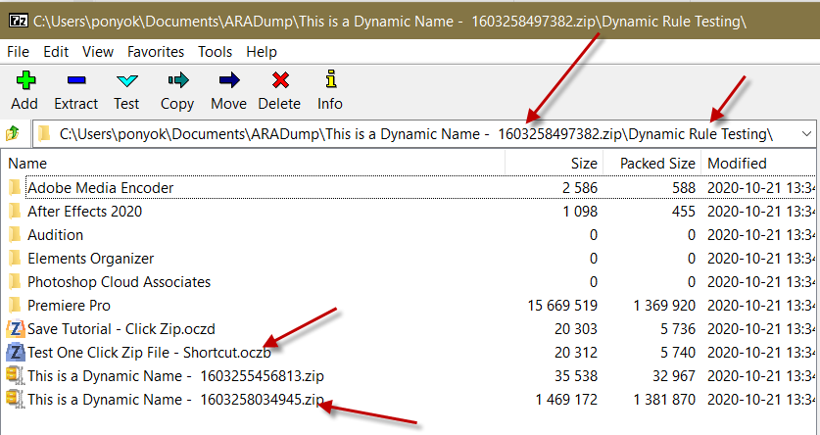](https://camo.githubusercontent.com/40beedb0b78c180dfe798c2970a99dec8c0044ad/68747470733a2f2f692e696d6775722e636f6d2f774d784b6b64532e706e67)

# Technologies

1. [Visual Studio Community Edition 2019](https://visualstudio.microsoft.com/downloads/)
2. C#
3. [.NET Framework 4.7](https://dotnet.microsoft.com/download/dotnet-framework/net47)
4. [ExpTreeLib 3.2.0](https://www.nuget.org/packages/ExpTreeLib/3.2.0?_src=template)
5. [Glob 1.1.8](https://www.nuget.org/packages/Glob/1.1.8?_src=template)
6. [Gimp](https://www.gimp.org/)
7. [DotNetZip](https://github.com/haf/DotNetZip.Semverd)